Federated Garden Club of Iowa, Inc.
www.gardenclubsofiowa.org
President 2017-2019:
Juliene Bramer
15677 110th Street
Greene IA 50636
641-823-9908 (h) 641-430-4430 (c)
mabramer@myomnitel.com

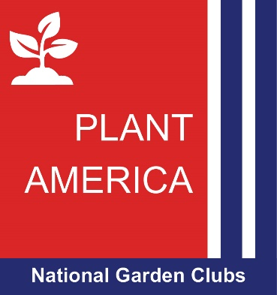

Theme: Plant America - A Grant Program and Fund

START ANEW - Plant, grow, wonder and remember…

Special Interests – Seed Savers & Geraniums

* * *
Recycle, Reuse and Reclaim – State President’s Project

A monetary award of $100 and certificate shall be awarded to the best FGCI’s Recycle, Reuse and Reclaim idea/project. Please submit a
brief summary to your FGCI State President by June 1.
Winner(s) will be announced at the 2018 and 2019 State Meetings.

