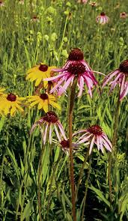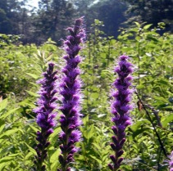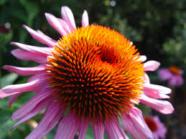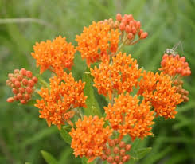

JUNE 29, 2015
8:30 A.M. to Approx. 3:30 P.M.
WILD FLOWER WORKSHOP
FEDERATED GARDEN CLUBS OF IOWA
at
WARREN COUNTY CONSERVATION ANNETTE CENTER
INDIANOLA, IOWA
SPEAKER:

LOREN LOWN,
Polk County Parks and Natural Prairies Planning Administrator
PRAIRIES
ANNETTE CENTER PRAIRIE
ANNETTE CENTER BUTTERFLY GARDEN
ROLLING THUNDER PRAIRIE
(One of the last virgin prairies in Iowa)
PRIVATE PRAIRIE IN THE PROCESS OF RESTORATION.
(Test plots on prairie restoration)

--------------------------------------------------------------
REGISTRATION FEE: $30.00 NAME: ______________________
Send check and registration to: ADDRESS: __________________
Darla Kickbush CITY: _______________________
707 West Third Ave, PHONE______________________
Indianola, Iowa 50125 EMAIL ______________________
Directions: Proceed to Hy. 65 South out of Indianola, to the Intersection to Aquabi State Park (there is a sign) Go West to Stop sign at Aquabi State Park Turn Right, Proceed to Annette Ctr.
There is a wind turbine at the Annette Ctr.

